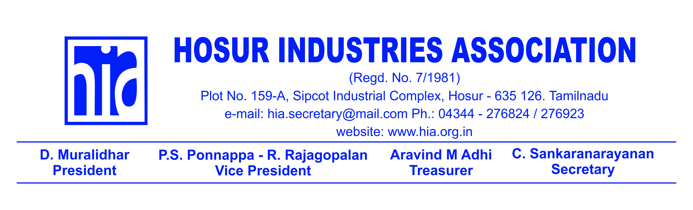
Ref: HIA/DIR/ Date: 12-03-2014

To,
All Members,

SUB: HOSUR BUSINESS DIRECTORY 2014-2014

You may be aware that HIA has so far brought out 4 editions of Industrial Directory since 2013, covering only Industries in Hosur. Now, HIA is bringing out HOSUR BUSINESS DIRECTORY 2014-2015, covering data base of all Industries, Trade, Commerce, Services, Educational Institutions, Entertainment and hospitality Industry in & around Hosur and neighbouring districts in Tamil Nadu and Karnataka. These being a well targeted discerning audience, it will be an effective sourcing tool for the development of your special area of interest through the media of Print & & digital media

I take this opportunity to appeal to you to kindly advertise in this important publication which would boost your brand equity and support the Association in its endeavor to enhance our members image and increase the Association revenue. I am sure you will take advantage of this offer and advertise in our Directory.

For further clarification if any you may contact:
Mr. Ramesh. M – 0900046446, Tel.: 080 – 65599001, 2, 3, 4 & 5

Thanking you,

Yours faithfully
For Hosur Industries Association

D. Muralidhar
President

2

TARIFF

SL. NO. | SIZE | DIMENSION | RATE
1 | 1 Unit Dimension | 6.2 x 12 cm | 6,000
2 | 2 Unit Dimension | 12.7 x 12 cm | 9,700
3 | Half Page Black & White | 19.2 x 12 cm | 13,200
4 | 2 Col | 12.7 x 24.5 cm | 18,000
5 | Full Page Black & White | 19.2 x 24.5 cm | 24,000
6 | Quarter Page Colour | 9.4 x 12 cm | 12,000
7 | Half Page Colour | 19.2 x 12 cm | 20,800
8 | Full Page Colour | 19.2 x 24.5 cm | 38,000
9 | Back Cover Page | 19.2 x 24.5 cm | 2,00,000
10 | Back Inner Cover Page | 19.2 x 24.5 cm | 1,75,000
11 | Front Inner Cover Page | 19.2 x 24.5 cm | 1,75,000

SPECIAL SECTION (WRITE UP)

1 | Half Page Colour | 19.2 x 12 cm | 20,800
2 | Full Page Colour | 19.2 x 24.5 cm | 38,000

COMPANY WRITE UP

1 | One Full Page | 19.2 x 24.5 cm | 45,000
2 | Two Full Page | 38.4 x 49 cm | 60,000

PAYMENT TERMS:

- 100% on Booking.
- All cheques should be in favour of Hosur Industries Association payable Hosur.
- Above Rates are for only one issue.
- Special discount for HIA Members.

